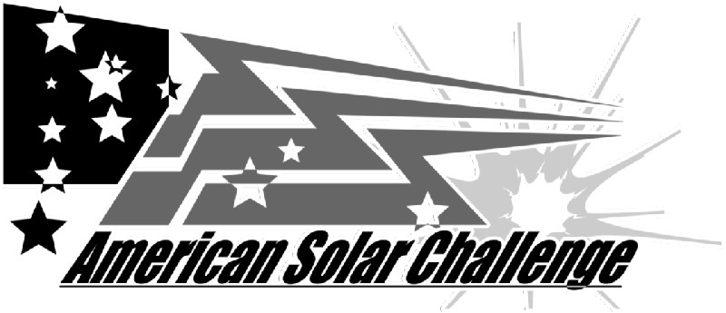 | ASC2010  Battery Form  Due: 2010.03.15, Submit to ASC Team Registration

NOTE: The manufacturer’s specification sheet, the battery’s MSDS sheet with accident protocol, and a description of the protection circuitry (protection circuitry schematic, high level description, list of items protected) must also be submitted to ASC prior to approval. Battery approval is subject to verification at Scrutineering. If the manufacturer changes the battery’s specifications, the new specifications must be submitted for re-approval. Teams should bring unmodified cells for weight verification.

CONTACT INFORMATION
Date: |  | Team Number:
Organization: |  | Team Battery Contact:
Email: |  | Phone:

MANUFACTURER INFORMATION
Manufacturer: |  | Type (lead acid, LION, etc):
Battery Name: |  | Model Number:
Battery Capacity (Ah): |  | Rate (C/3, C/20, etc):
Battery Mass (kg): |  | Battery Voltage:
Battery Cost (US$): |  | Max Current per Cell:

VEHICLE BATTERY PACK SPECIFICATIONS
Number of batteries in the vehicle battery pack :
Pack Mass (kg): |  | Pack Voltage:
Pack Configuration:

SUPPLIER INFORMATION

Information for the company that is supplying the batteries to the team. This may be the original manufacturer or a reseller. If the supplier uses a different model name or number than the manufacturer, please provide that information.
Supplier: |  | Contact:
Email: |  | Phone:
Supplier Battery Name: |  | Supplier Model #:

Note: For this form, the term “battery” refers to the smallest single unit produced by the manufacturer. A lithium ion battery usually contains one cell. A typical 12v lead acid battery contains six cells. Teams or suppliers may group batteries together to form "modules". The term “battery pack” refers to the full vehicle battery system made up of multiple batteries.

